
Pre-Prep Summer School Menu: Week One
BREAKFAST
 | MONDAY | TUESDAY | WEDNESDAY | THURSDAY | FRIDAY
  Main | Fried Eggs &  Baked Rosti Potatoes  Multi Grain Hoops | Boiled Eggs,  Rice Krispies | Grilled Back Bacon with Grilled Tomato,  Blueberry Wheats | Danish Pastries,  Cornflakes | Grilled Sausages & Baked Beans,  Malted Wheats
Accompaniment | Served daily with fruit cart, cereals, porridge, toast and preserves
LUNCH
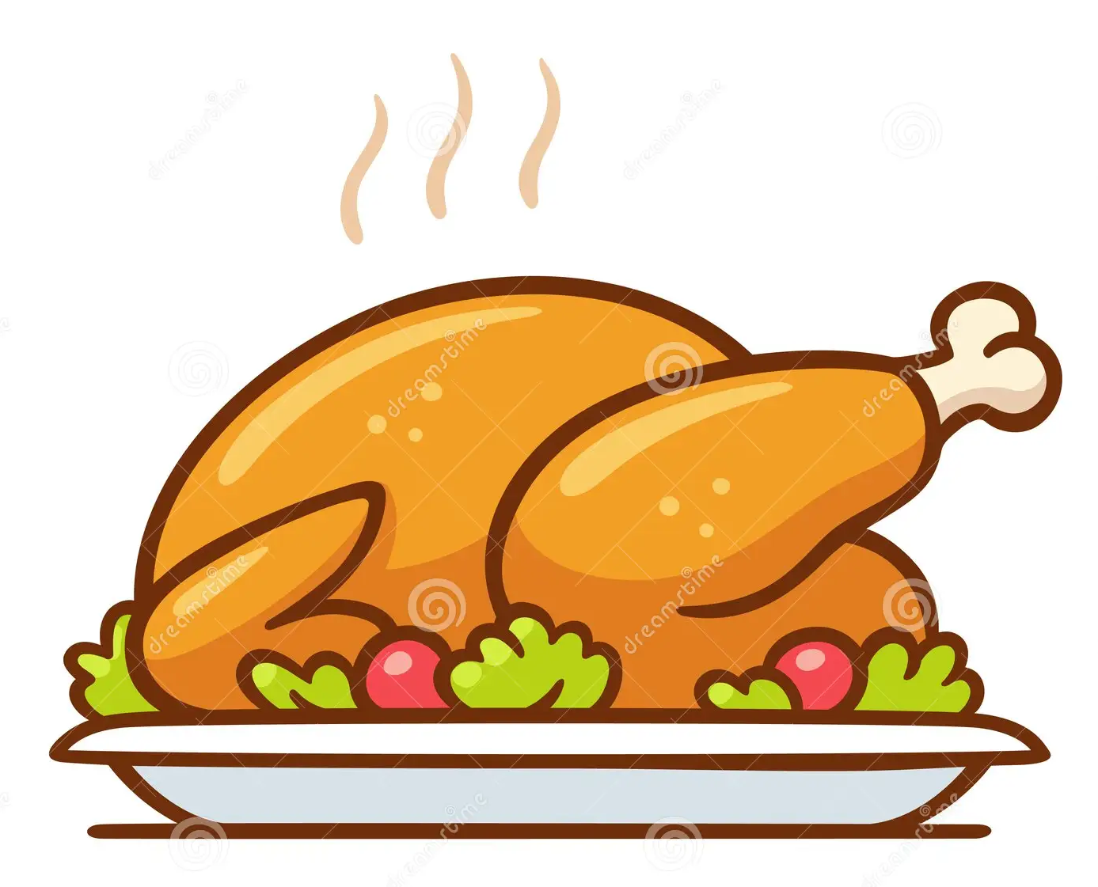  Main Course | Moroccan Chicken Thighs, in a Tomato & Herb Sauce  with Bulgar Wheat | Grilled Pork Sausage | Beef Chilli Con Carni with steamed Brown Rice | Beef Burger  BBQ chicken Thigh | Roasted Breast of Chicken  Served with Hummus & Crudities
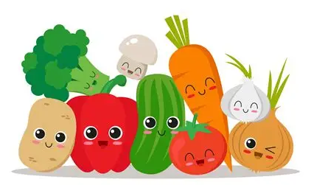  Vegetables | Roasted Vegetables & Green Beans | Mashed Potatoes & Baked Beans | Guacamole, Salsa, Sour Cream and Taco Shells | A Selection of Freshly Prepared Salads | Skinny Fries  Steamed Peas
  Pudding | Fresh Fruit Salad | Raspberry Jelly with  Fresh Cream | Greek Natural Yoghurt, with Seeds & Fruit Compote | Fruit Ice Lolly | Fresh Strawberries with Peaches
SUPPER
  Main Course | Quiche Lorraine  Sauté Potatoes & Steamed Broccoli Florets | Cottage Pie in a Rich Beef Gravy,  With Peas & Carrots | Baked Jacket Potatoes,  Various Proteins & Salads | Tomato & Basil Pasta Bake, served with Garlic Bread & Crudities | Garlic Chicken Thighs served with Baby Steamed Potatoes, Peas & Sugar Snaps
  Pudding | Low fat natural yoghurt and fruit available | Low fat natural yoghurt and fruit available | Low fat natural yoghurt and fruit available | Low fat natural yoghurt and fruit available | Low fat natural yoghurt and fruit available
Accompaniment | Lunch & Supper Served daily with a selection of freshly prepared salads and proteins
Pre-Prep Summer School Menu: Week Two
BREAKFAST
 | MONDAY | TUESDAY | WEDNESDAY | THURSDAY | FRIDAY
Main | Potato Rosti with Fried Eggs  Multi Grain Hoops | Boiled Eggs,  Rice Krispies | Grilled Back Bacon with Grilled Tomato,  Blueberry Wheats | Danish Pastries,  Cornflakes | Grilled Sausages & Baked Beans,  Malted Wheats
Accompaniment | Served daily with fruit cart, cereals, porridge, toast and preserves
LUNCH
Main Course | Paprika Chicken & Potato bake, with Cherry Tomatoes & Parsley | Chicken Korma with  Naan Bread, Chutney & Steamed Rice | Beef Lasagne  In a Rich Ragu Sauce | BBQ  Hot Dogs & Onions  Lamb Koftas  Minted Crème Fraiche | Battered Fillet of Cod, with Chunky Chips
Vegetables | Mixed Salad Leaves  Pepper & Carrot Sticks | Steamed Rice,  & Cauliflower Florets | Steamed Broccoli Florets & Garlic Bread Slices | A Selection of Freshly Prepared Salads | Steamed Peas, & Tartare Sauce
Pudding | Fresh Fruit Salad | Greek Natural Yoghurt, with Seeds & Fruit Compote | Raspberry & Peach Salad | Fruit Ice Lolly | Fresh Berry Medley with Fresh Cream
SUPPER
Main Course | Pesto Tagliatelle served alongside Garlic Bread Slices | Chicken Enchiladas  Served with Salads | Chicken Tikka Thighs  Steamed Rice & Mango Chutney, with Green Beans | Fusilli Pasta, in a Creamy Garlic Sauce, with Spinach & Peas | Chilli Con Carne  Steamed Rice, Tortilla Crisps,  Guacamole & Salsa
Pudding | Low fat natural yoghurt and fruit available | Low fat natural yoghurt and fruit available | Low fat natural yoghurt and fruit available | Low fat natural yoghurt and fruit available | Low fat natural yoghurt and fruit available
Accompaniment | Lunch & Supper Served daily with a selection of freshly prepared salads and proteins
Pre-Prep Summer School Menu: Week Three
BREAKFAST
 | MONDAY | TUESDAY | WEDNESDAY | THURSDAY | FRIDAY
Main | Baked Hash Brown with Fried Eggs  Multi Grain Hoops | Boiled Eggs,  Rice Krispies | Grilled Back Bacon with Grilled Tomato,  Blueberry Wheats | Danish Pastries,  Cornflakes | Grilled Sausages & Baked Beans,  Malted Wheats
Accompaniment | Served daily with fruit cart, cereals, porridge, toast and preserves
LUNCH
Main Course | Spaghetti & Meatballs in a Rich Tomato & Herb Sauce | Chicken Tikka Masala, Mango Chutney & Naan Bread | Chicken, Ham & Leek Risotto  With Parmesan Cheese | Beef Burger &  Boneless Chicken Thighs | Baked Fish Fingers  Served with Tartare Sauce
Vegetables | Steamed Broccoli Florets | Cauliflower Florets & Green Beans | Carrots, Peas and Sweetcorn | A Selection of Freshly Prepared Salads | Skinny Fries & Steamed Peas
Pudding | Raspberry & Peach Salad | Fruit Jelly with Fresh Cream | Greek Natural Yoghurt, with Seeds & Fruit Compote | Fruit Ice Lolly | Fresh Strawberries
SUPPER
Main Course | Tomato and Basil Pasta with Fresh Spinach, served with Petit Pains | Various Baked Pizzas  Vegetable Crudities | Honey Roast Gammon with Cheesy Leeks & Parmentier Potatoes | Sausage roll  Mashed Potatoes & Baked Beans | Katsu Chicken Curry  Egg Noodles, Steamed Broccoli
Pudding | Low fat natural yoghurt and fruit available | Low fat natural yoghurt and fruit available | Low fat natural yoghurt and fruit available | Low fat natural yoghurt and fruit available | Low fat natural yoghurt and fruit available
Accompaniment | Lunch & Supper Served daily with a selection of freshly prepared salads and proteins

