Walled Garden Autumn School Menu: Week One 
BREAKFAST
 | MONDAY | TUESDAY | WEDNESDAY | THURSDAY | FRIDAY | SATURDAY | SUNDAY
  Main | Fried Eggs and  Potato Waffle | Boiled Eggs  Served alongside  Fresh Fruit Slices | Toasted Crumpets  Grilled Bacon &  Tomato | Freshly Baked  Croissants | Grilled Pork  Sausages  & Baked Beans | Scrambled Egg with  Hash Browns | Freshly Baked  Croissants  Full English  Cooked Breakfast
Accompaniment | Served daily with fruit cart, cereals, porridge, toast and preserves

LUNCH
 | MONDAY | TUESDAY | WEDNESDAY | THURSDAY | FRIDAY | SATURDAY | SUNDAY
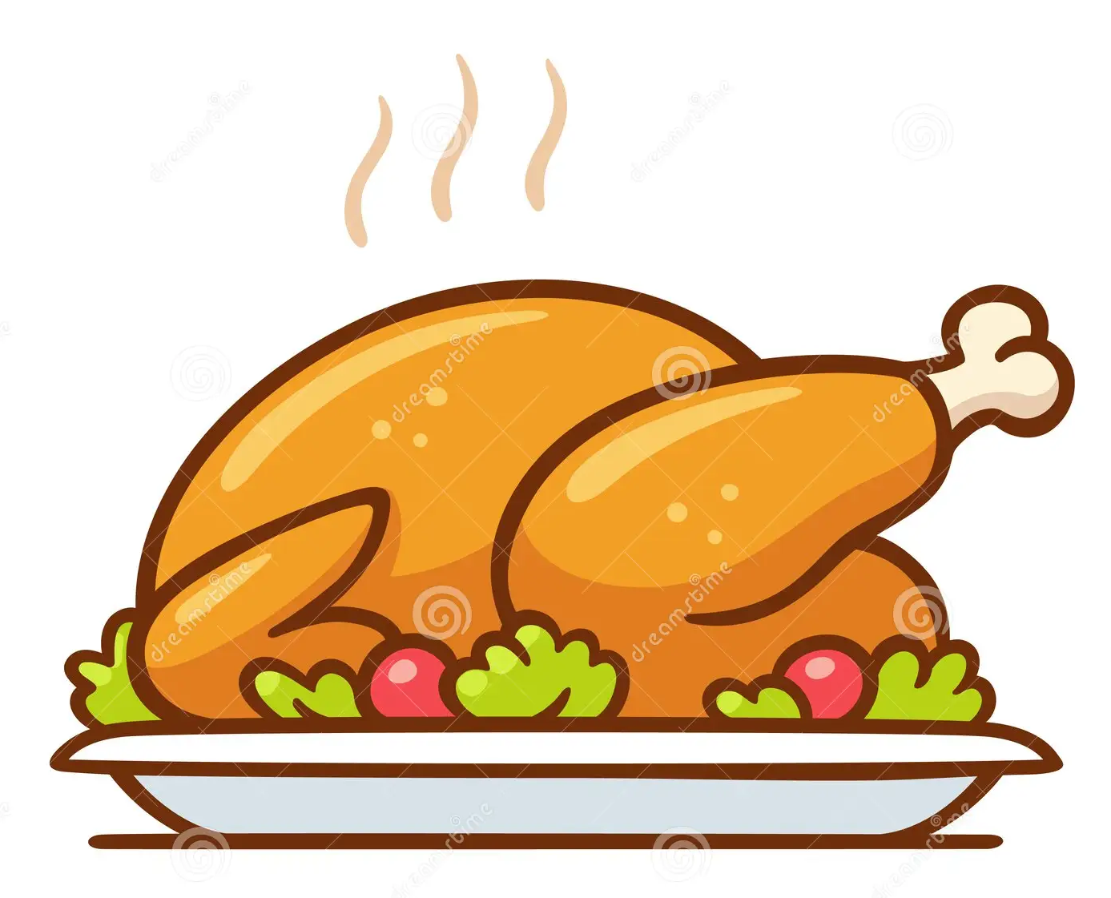  Main Course | Beef Chilli Con  Carne  Steamed Basmati Rice  Crisp Tortillas  Guacamole & Salsa | Grilled Pork  Sausages, with  Creamy  Mashed Potatoes &  Baked Beans | Spaghetti Bolognese in a Rich Ragu Sauce  Served with Freshly  Grated Parmesan  Cheese | Roast Breast of  Chicken  with Herb Stuffing &  Roast Chicken Gravy | Battered Fish & Chips  with Fresh Lemon &  Tartare Sauce | Glazed Pork Steaks  with Honey &  Mustard  served with Thyme  Jus | Roast Topside Of Beef  Yorkshire Puddings  Beef Gravy &  Horseradish Sauce
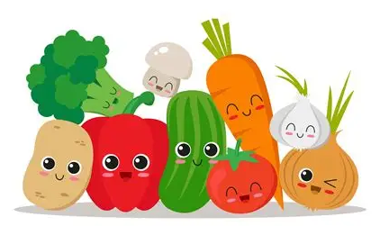  Vegetables | Baton Carrots  Steamed Cabbage  Boiled Potatoes | Creamed Potatoes  & Baked Beans | Garlic Bread Slices  Freshly Prepared  Salad | Cauliflower &  Broccoli Florets  Roasted Baby  Potatoes | Chunky Chips  Steamed Peas  & Tartare Sauce | Roasted Baby  Potatoes  Sliced Cabbage &  Broccoli Florets | Roast Potatoes  Honey Roast Parsnips  Braised Red Cabbage  & Broccoli Florets
  Pudding | Sliced Watermelon | Natural Greek Yogurt  Forest Fruit Compote  Or Fresh Fruit | Baked Apple & Pear Oat Crumble with Cream | Pip Ice Lollies  Or Fresh Fruit | Poached Pears with Natural Greek Yoghurt  Or Fresh Fruit

SUPPER
 | MONDAY | TUESDAY | WEDNESDAY | THURSDAY | FRIDAY | SATURDAY | SUNDAY
  Main Course | Baked Potatoes  Cheese, Ham, Tuna,  Baked Beans, Chicken  Salad Bar | Chicken & Chorizo  Pasta in a Tomato  Sauce  with Garlic Bread  Salad Bar & Proteins | BBQ Pulled Pork  Sourdough Roll  Apple Sauce  Crudities & Salad Bar | Pizza Assortment  Served with  Steamed Peas & Corn  Salad Bar & Proteins | Pesto Tagliatelle  Roasted Vegetables  Sour Dough Bread  Salad Bar & Proteins | Garlic Chicken  Breast  Steamed Peas,  Buttered Baby  Potatoes  Salad Bar & Proteins | Cheddar Cheese  & Ham Paninis  Tomato Soup  Salad Bar & Proteins
  Pudding | Freshly Baked  Flapjack | Carrot Cake | Chilled Water Melon  Slices | Courgette Cake with | Classic School  Sponge Cake | Chocolate Sponge  Cake, with Sprinkles | Home Baked Cookies
Accompaniment | Lunch & Supper Served daily with a selection of freshly prepared salads and proteins

Walled Garden Autumn School Menu: Week Two
BREAKFAST
 | MONDAY | TUESDAY | WEDNESDAY | THURSDAY | FRIDAY | SATURDAY | SUNDAY
Main | Fried Eggs and  Potato Waffle | Boiled Eggs  Served alongside  Fresh Fruit Slices | Toasted Crumpets  Grilled Bacon &  Tomato | Freshly Baked  Croissants | Grilled Pork  Sausages  & Baked Beans | Scrambled Egg with  Hash Browns | Freshly Baked  Croissants  Full English  Cooked Breakfast
Accompaniment | Served daily with fruit cart, cereals, porridge, toast and preserves

LUNCH
 | MONDAY | TUESDAY | WEDNESDAY | THURSDAY | FRIDAY | SATURDAY | SUNDAY
Main Course | Sweet & Sour  Chicken  With Prawn Crackers | Spaghetti &  Meatballs  In a Rich Tomato &  Herb Sauce, Served With  Grated Parmesan | Roast Pork Loin  with Herb Stuffing  & Apple Sauce | Chicken & Bacon Pasta  in a Creamy Herb Sauce | Breaded Fish Fingers,  & Chunky Chips  with Fresh Lemon &  Tartare Sauce | Beef Curry  Naan Bread  Cucumber Riata  Mango Chutney | Baked Gammon  with Herb Stuffing  & Pan Gravy
Vegetables | Egg Fried Rice  Cauliflower Florets  & French Beans | Freshly Prepared  Salads &  Crusty Warm Bread | Roast Potatoes  Broccoli Florets  Baton Carrots | Baby Steamed  Potatoes  Broccoli Florets  Sliced Savoy Cabbage | Chunky Chips  & Steamed Peas | Fragrant Steamed  Rice  Spiced Cauliflower  Florets | Roast Potatoes  Creamed Leeks  Carrots & Swede Puree  Roasted Honey  Parsnips
Pudding | Fresh Fruit Salad | Natural Yogurt  Fruit Compote  Or Fresh Fruit | Sliced Honeydew Melon | Pip Ice Lollies  Or Fresh Fruit | Stewed Apple & Raspberries with Cream

SUPPER
 | MONDAY | TUESDAY | WEDNESDAY | THURSDAY | FRIDAY | SATURDAY | SUNDAY
Main Course | Cod Goujons  Skinny Fries  Peas  Salad Bar & Proteins | Margarita Pizza  Various Toppings  Salad Bar | Katsu Chicken Curry  with Egg Noodles &  Roasted Vegetables  Salad Bar & Proteins | Home Cooked  Gammon  Ham with Baked Beans  & Sauté Potatoes  Salad Bar & Proteins | Fusilli Pasta with  Bacon & Cheese,  Steamed Broccoli  Florets  Salad Bar & Proteins | Garlic Chicken  Thighs,  Roasted Baby  Potatoes  Peas & Carrots  Salad Bar & Protein | Grilled Pork  Sausages  With Creamy Mashed  Potatoes &  Baked Beans  Salad Bar & Proteins
Pudding | Freshly Baked  Flapjack | Carrot Cake | Chilled Water Melon  Slices | Courgette Cake with | Classic School  Sponge Cake | Chocolate Sponge  Cake, with Sprinkles | Home Baked Cookies
Accompaniment | Lunch & Supper Served daily with a selection of freshly prepared salads and proteins
Walled Garden Autumn School Menu: Week Three
BREAKFAST
 | MONDAY | TUESDAY | WEDNESDAY | THURSDAY | FRIDAY | SATURDAY | SUNDAY
Main | Fried Eggs and  Potato Waffle | Boiled Eggs  Served alongside  Fresh Fruit Slices | Toasted Crumpets  Grilled Bacon &  Tomato | Freshly Baked  Croissants | Grilled Pork  Sausages  & Baked Beans | Scrambled Egg with  Hash Browns | Freshly Baked  Croissants  Full English  Cooked Breakfast
Accompaniment | Served daily with fruit cart, cereals, porridge, toast and preserves

LUNCH
 | MONDAY | TUESDAY | WEDNESDAY | THURSDAY | FRIDAY | SATURDAY | SUNDAY
Main Course | Cottage Pie in a Rich  Beef Gravy, Topped  With Creamy Mashed  Potatoes | Pork Stroganoff  In a Mustard & Paprika  Cream Sauce | Chicken & Chorizo  Risotto  Served with Crusty  Sliced Bread | Chicken Tikka Masala  Steamed Basmati Rice  Coriander Riata  Mango Chutney  Naan Bread | Battered Fish & Chips  with Fresh Lemon &  Tartare Sauce | Baked Salmon Fillet  with a White Wine & Chive Sauce | Roast Lamb  Mint Sauce  Gravy
Vegetables | Steamed Peas With  Sweetcorn &  Broccoli Florets | Rice  Steamed Baton  Carrots | Sliced Steamed Cabbage | Cauliflower Florets &  Steamed Whole Beans | Chunky Chips &  Steamed Peas | French Beans &  Sugar Snap Peas | Dauphinois Potatoes  Roasted Carrots  Red Cabbage  Roasted Parsnips
Pudding | Sliced Watermelon | Natural Greek Yogurt  Forest Fruit Compote  Or Fresh Fruit | Baked Apple & Pear Oat Crumble with Cream | Pip Ice Lollies  Or Fresh Fruit | Poached Pears with Natural Greek Yoghurt  Or Fresh Fruit

SUPPER
 | MONDAY | TUESDAY | WEDNESDAY | THURSDAY | FRIDAY | SATURDAY | SUNDAY
Main Course | Tomato & Basil Pasta  Garlic Bread  Roasted Vegetables  Salad Bar & Proteins | Salt & Pepper  Chicken  Chips  Salad Bar & Proteins | Ham And Cheese  Panier  Baby Steamed  Potatoes  Peas & Spinach  Salad Bar & Proteins | Cheese Burger &  Onion  Sauté Potatoes  Baked Beans  Salad Bar & Proteins | Baked Potatoes with Beef Chilli Con Carni  Salad Bar & Proteins | Crispy Chilli Beef  Noodles  Stir Fried Vegetables  Salad Bar & Proteins | Freshly Made Soup  With Cheese  Baguette  Salad Bar & Proteins
Pudding | Freshly Baked  Flapjack | Carrot Cake | Chilled Water Melon  Slices | Courgette Cake with | Classic School  Sponge Cake | Chocolate Sponge  Cake, with Sprinkles | Home Baked Cookies
Accompaniment | Lunch & Supper Served daily with a selection of freshly prepared salads and proteins

