Our Summer School Menu: Week One 
BREAKFAST
 | MONDAY | TUESDAY | WEDNESDAY | THURSDAY | FRIDAY | SATURDAY | SUNDAY
  Main | Fried Eggs &  Baked Rosti Potatoes | Boiled Eggs,  Sliced Fruits | Grilled Back Bacon with Grilled Tomato, | Danish Pastries, | Grilled Sausages & Baked Beans, | Scrambled Egg & Baked Hash Browns, | Bacon & Cheese Puff, with Baked Beans.  Danish Pastries,
Accompaniment | Served daily with fruit cart, cereals, porridge, toast and preserves
LUNCH
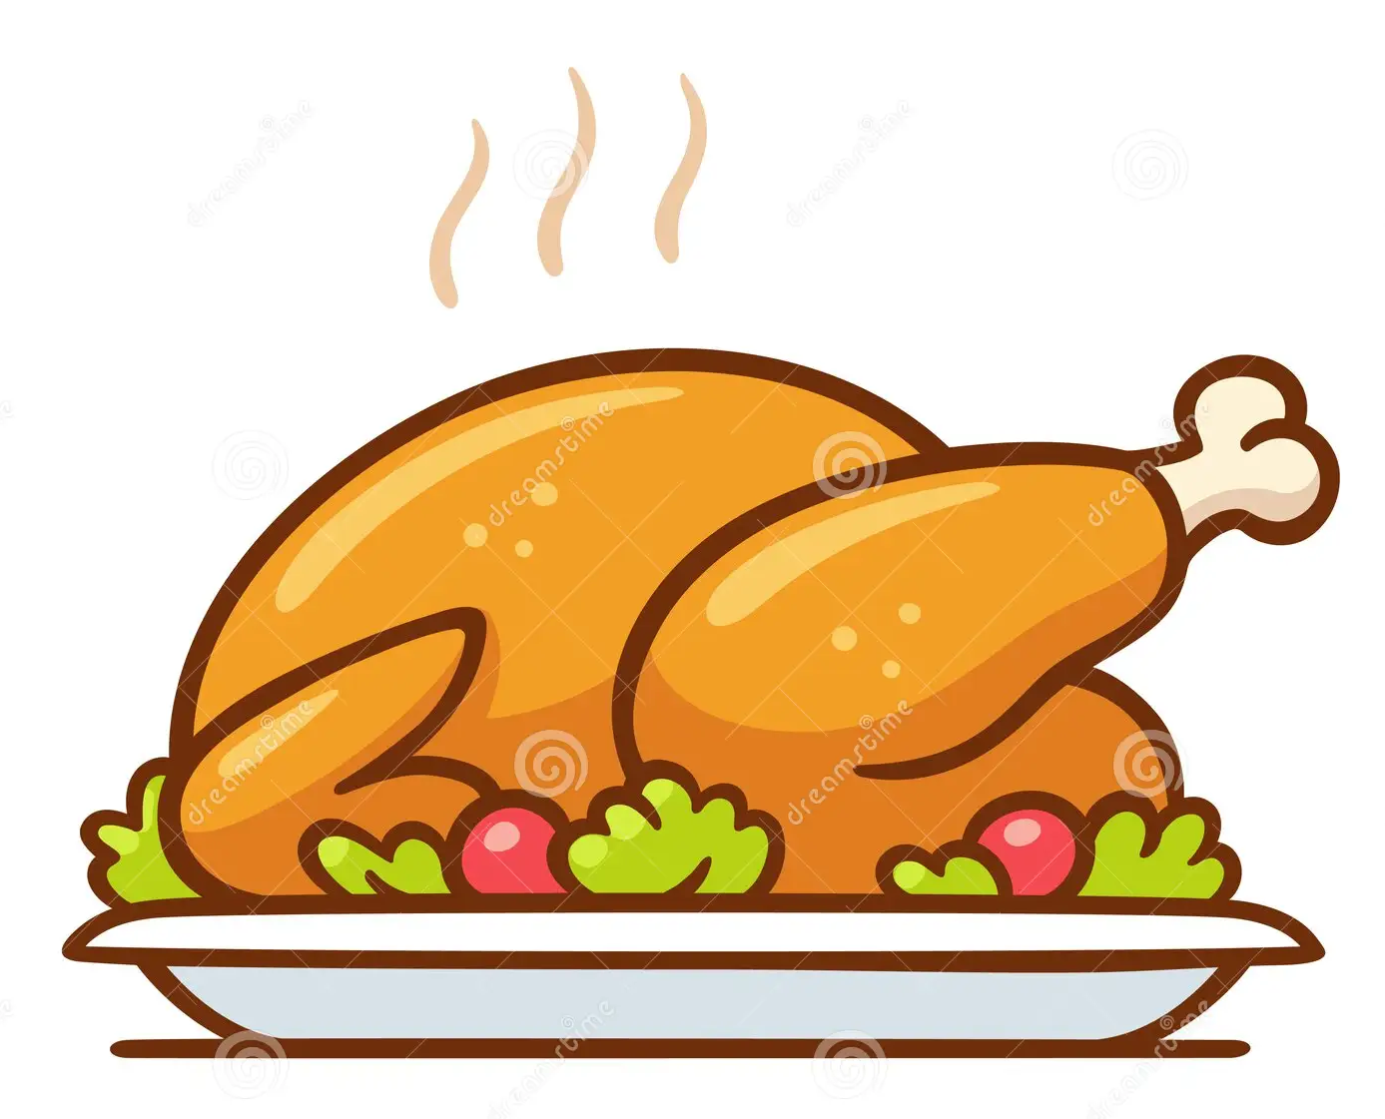  Main Course | Moroccan Chicken Thighs, in a Tomato & Herb Sauce  with Bulgar Wheat | Grilled Pork Sausage | Beef Chilli Con Carne  Served with Brown Rice | BBQ  Beef Burger  BBQ chicken Thigh | Roasted Breast of Chicken  Served with Hummus & Crudities | Chinese Pork with  Prawn Crackers &  Egg Noodles | Roast Leg of Lamb  Dauphinoise Potatoes served with Rosemary Jus & Mint Sauce
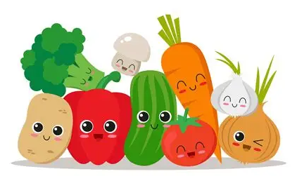  Vegetables | Roasted Vegetables & Green Beans | Mashed Potatoes & Baked Beans | Served with Tacos, Guacamole, Salsa & Sour Cream | A Selection of Freshly Prepared Salads | Skinny Fries  Steamed Peas | Steamed Broccoli Florets | Braised Red Cabbage, Cauliflower Cheese & Steamed Carrots
  Pudding | Fresh Fruit Salad  Served with Fresh Cream | Raspberry Jelly &  Dairy Vanilla  Ice Cream | Natural Greek Yoghurt, Forest Fruit Compote & Granola | Ice Cream Thursday | Steamed Chocolate Sponge Pudding with Chocolate Custard | Waffles with Vanilla Ice Cream | Chocolate Fudge Cake, with Fresh Dairy Cream
SUPPER
  Main Course | Quiche Lorraine  Sauté Potatoes & Steamed Broccoli Florets | Garlic Chicken Thighs served with Baby Steamed Potatoes, Peas & Sugar Snaps | Baked Jacket Potatoes,  Various Proteins & Salads | Tomato & Basil Pasta Bake, served with Garlic Bread & Crudities | Cottage Pie in a Rich Beef Gravy,  With Steamed Carrots | Spaghetti Bolognaise with Grated Grana Padano  & Crusty Bread | Tomato Soup  Freshly Baked Baguettes with Various Fillings
  Pudding | Baked School Sponge Cake | Courgette Cake | Seeded Flapjack | Chocolate Krispie Slice | Carrot Cake with Orange Frosting | Freshly Baked Cookies | Iced Water Melon
Accompaniment | Lunch & Supper Served daily with a selection of freshly prepared salads and proteins
Our Summer School Menu: Week Two
BREAKFAST
 | MONDAY | TUESDAY | WEDNESDAY | THURSDAY | FRIDAY | SATURDAY | SUNDAY
Main | Potato Rosti with Fried Eggs | Boiled Eggs,  Sliced Fruits | Grilled Back Bacon with Grilled Tomato, | Danish Pastries, | Grilled Sausages & Baked Beans, | Scrambled Egg & Baked Hash Browns, | Full English  Breakfast
Accompaniment | Served daily with fruit cart, cereals, porridge, toast and preserves
LUNCH
Main Course | Paprika Chicken & Potato bake, with Cherry Tomatoes & Parsley | Chicken Korma with  Naan Bread, Chutney & Steamed Rice | Beef Lasagne  In a Rich Ragu Sauce | BBQ  Hot Dogs & Onions  Lamb Koftas  Minted Crème Fraiche | Battered Fillet of Cod, with Chunky Chips | Steamed Fillet of Salmon, with a White Wine & Chive Cream Sauce | Roast Beef & Horseradish Sauce,  Yorkshire Puddings,  Beef Gravy
Vegetables | Mixed Salad Leaves  Pepper & Carrot Sticks & Hummus Dip | Steamed Rice,  & Cauliflower Florets | Steamed Broccoli Florets & Garlic Bread Slices | A Selection of Freshly Prepared Salads | Steamed Peas, & Tartare Sauce | Steamed Baby Potatoes, Carrot, Green Beans & Sugar Snap Medley | Roast Potatoes,  Steamed Cabbage,  Broccoli Florets, & Roasted Parsnips & Carrots
Pudding | Dairy Profiteroles with Caramel Sauce | Apple Strudel with Custard | Lemon Meringue Pie  Dairy Cream | Ice Cream Thursday | Treacle Sponge & Custard | Raspberry Meringue Roulade Filled with Fresh Cream | Blueberry Muffins & Fresh Dairy Cream
SUPPER
Main Course | Chilli Con Carni  Steamed Rice, Tortilla Crisps,  Guacamole & Salsa | Pesto Tagliatelle served alongside Garlic Bread Slices | Chicken Tikka Thighs  Steamed Rice & Mango Chutney, with Green Beans | Fusilli Pasta, in a Creamy Garlic Sauce, with Spinach & Peas | Chicken Enchiladas  Served with Salads | Grilled pork Steak  Roasted Baby Potatoes, Sautéed Cabbage | Ham & Cheese Panini served with Fresh Homemade Soup
Pudding | Baked School Sponge Cake | Courgette Cake | Seeded Flapjack | Chocolate Krispie Slice | Carrot Cake with Orange Frosting | Freshly Baked Cookies | Iced Water Melon
Accompaniment | Lunch & Supper Served daily with a selection of freshly prepared salads and proteins
Our Summer School Menu: Week Three
BREAKFAST
 | MONDAY | TUESDAY | WEDNESDAY | THURSDAY | FRIDAY | SATURDAY | SUNDAY
Main | Baked Hash Brown with Fried Eggs | Boiled Eggs,  Sliced Fruits | Grilled Back Bacon with Grilled Tomato, | Danish Pastries, | Grilled Sausages & Baked Beans, | Scrambled Egg & Baked Hash Browns, | Full English  Breakfast
Accompaniment | Served daily with fruit cart, cereals, porridge, toast and preserves
LUNCH
Main Course | Spaghetti & Meatballs in a Rich Tomato & Herb Sauce | Chicken Tikka Masala, Mango Chutney & Naan Bread | Chicken, Bacon & Leek Risotto  With Parmesan Cheese | BBQ  Beef Burger &  Boneless Chicken Thighs | Baked Fish Fingers  Tartare Sauce | Bacon Cheese & Spinach Pasta Bake, Topped with Toasted Cheese duo | Roast Loin of Pork  & Apple Sauce,  with Thyme Jus
Vegetables | Steamed Broccoli Florets | Cauliflower Florets & Green Beans | Served with Carrots, Peas and Sweetcorn | A Selection of Freshly Prepared Salads | Skinny Fries & Steamed Peas | Roasted Vegetable Medley | Cauliflower Cheese  Sautéed Cabbage & Baton Carrots
Pudding | Peach & Raspberry Crumble with Fresh Cream | Strawberry Jelly with Vanilla Ice Cream | Natural Greek Yoghurt, Forest Fruit Compote & Granola | Ice Cream Thursday | Jam Sponge & Dairy Custard | Strawberry Gateaux  With Fresh Cream | Banoffee Pie  With fresh Cream
SUPPER
Main Course | Sausage roll  Mashed Potatoes & Baked Beans | Various Baked Pizzas  Vegetable Crudities | Honey Roast Gammon with Cheesy Leeks & Parmentier Potatoes | Tomato and Basil Pasta with Fresh Spinach, served with Petit Pains | Katsu Chicken Curry  Egg Noodles, Steamed Broccoli | Grilled Chicken Breast, Steamed Potatoes Peas & Sugar Snaps | Sausage & Onion Baguettes, served alongside Sauté Potatoes
Pudding | Baked School Sponge Cake | Courgette Cake | Seeded Flapjack | Chocolate Krispie Slice | Carrot Cake with Orange Frosting | Freshly Baked Cookies | Iced Water Melon
Accompaniment | Lunch & Supper Served daily with a selection of freshly prepared salads and proteins

