Our Autumn School Menu: Week One 
BREAKFAST
 | MONDAY | TUESDAY | WEDNESDAY | THURSDAY | FRIDAY | SATURDAY | SUNDAY
  Main | Fried Eggs and  Potato Waffle | Boiled Eggs  served alongside  Fresh Fruit Slices | Toasted Crumpets  Grilled Bacon &  Tomato | Freshly Baked  Croissants | Grilled Pork  Sausages  & Baked Beans | Scrambled Egg with  Hash Browns | Freshly Baked  Croissants  Full English  Cooked Breakfast
Accompaniment | Served daily with fruit cart, cereals, porridge, toast and preserves

LUNCH
 | MONDAY | TUESDAY | WEDNESDAY | THURSDAY | FRIDAY | SATURDAY | SUNDAY
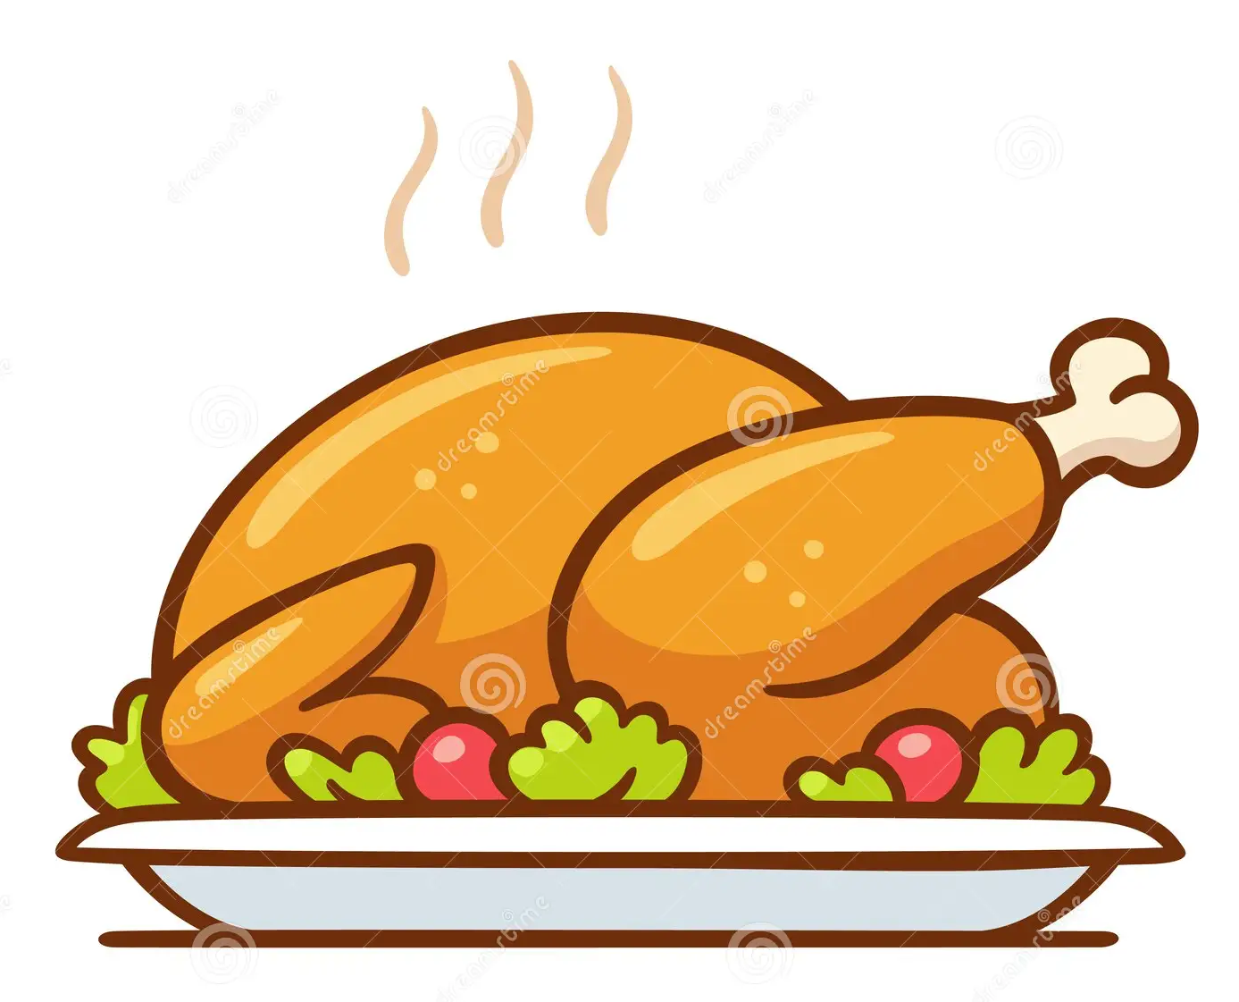  Main Course | Beef Chilli Con Carne  Steamed Basmati Rice  Crisp Tortillas  Guacamole & Salsa | Grilled Pork  Sausages, with  Creamy  Mashed Potatoes &  Baked Beans | Spaghetti Bolognese  in a Rich Ragu Sauce  served with Freshly  Grated Parmesan  Cheese | Roast Breast of  Chicken  with Herb Stuffing &  Roast Chicken Gravy | Battered Fish & Chips  with Fresh Lemon &  Tartare Sauce | Glazed Pork Steaks  with Honey &  Mustard  served with Thyme  Jus | Roast Topside of Beef  Yorkshire Puddings  Beef Gravy &  Horseradish Sauce
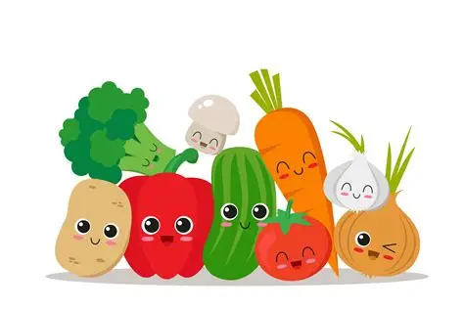  Vegetables | Steamed Broccoli  & Rice | Creamed Potatoes  Baked Beans | Garlic Bread Slices  Freshly Prepared  Salad | Cauliflower &  Broccoli Florets  Roasted Baby  Potatoes | Chunky Chips  Steamed Peas  Tartare Sauce | Roasted Baby  Potatoes  Sliced Cabbage &  Broccoli Florets | Roast Potatoes  Honey Roast Parsnips  Braised Red Cabbage  Broccoli Florets
  Pudding | Belgian Waffles  Vanilla Ice Cream  Caramel Sauce  or Fresh Fruit | Natural Greek  Yogurt  Forest Fruit Compote  Pumpkin & Sunflower  Seeds  or Fresh Fruit | Apple & Sultana  Crumble With  Cinnamon  And Dairy Custard  or Fresh Fruit | Ice Cream Thursday  or Fresh Fruit | Jam Sponge & Dairy Custard  or Fresh Fruit | Baked Rice Pudding  Served With  Preserves  or Fresh Fruit | Lemon Meringue Pie  With Fresh Double  Pouring Cream  or Fresh Fruit

SUPPER
 | MONDAY | TUESDAY | WEDNESDAY | THURSDAY | FRIDAY | SATURDAY | SUNDAY
  Main Course | Baked Potatoes  Cheese, Ham, Tuna,  Baked Beans, Chicken  Salad Bar | Chicken & Chorizo  Pasta in a Tomato  Sauce  with Garlic Bread  Salad Bar & Proteins | BBQ Pulled Pork  Sourdough Roll  Apple Sauce  Crudities & Salad Bar | Pizza Assortment  Served with  Steamed Peas & Corn  Salad Bar & Proteins | Pesto Tagliatelle  Roasted Vegetables  Garlic Bread  Salad Bar & Proteins | Garlic Chicken  Breast  Steamed Peas,  Buttered Baby  Potatoes  Salad Bar & Proteins | Cheddar Cheese  & Ham Paninis  Tomato Soup  Salad Bar & Proteins
Pudding   | Freshly Baked  Flapjack | Carrot Cake | Chilled Water Melon  Slices | Courgette Cake | Classic School  Sponge Cake | Chocolate Sponge  Cake, with Sprinkles | Home Baked Cookies
Accompaniment | Lunch & Supper Served daily with a selection of freshly prepared salads and proteins, Fresh Fruits & Natural Greek Yoghurt
Our Autumn School Menu: Week Two
BREAKFAST
 | MONDAY | TUESDAY | WEDNESDAY | THURSDAY | FRIDAY | SATURDAY | SUNDAY
Main | Fried Eggs and  Potato Waffle | Boiled Eggs  served alongside  Fresh Fruit Slices | Toasted Crumpets  Grilled Bacon &  Tomato | Freshly Baked  Croissants | Grilled Pork  Sausages  & Baked Beans | Scrambled Egg with  Hash Browns | Freshly Baked  Croissants  Full English  Cooked Breakfast
Accompaniment | Served daily with fruit cart, cereals, porridge, toast and preserves

LUNCH
 | MONDAY | TUESDAY | WEDNESDAY | THURSDAY | FRIDAY | SATURDAY | SUNDAY
Main Course | Sweet & Sour  Chicken  with Prawn Crackers | Spaghetti &  Meatballs  in a Rich Tomato &  Herb Sauce,  served with  Grated Parmesan | Roast Pork Loin  with Herb Stuffing  & Apple Sauce | Chicken & Bacon  Pasta, in a  Creamy Herb Sauce | Breaded Fish Fingers,  with Fresh Lemon &  Tartare Sauce | Beef Curry  Naan Bread  Cucumber Riata  Mango Chutney | Baked Gammon  With Herb Stuffing  & Pan Gravy
Vegetables | Egg Fried Rice  Cauliflower Florets  & French Beans | Freshly Prepared  Salads & | Roast Potatoes  Broccoli Florets  Baton Carrots | Broccoli Florets  Sliced Savoy Cabbage | Chips  & Steamed Peas | Fragrant Steamed  Rice  Spiced Cauliflower  Florets | Roast Potatoes  Creamed Leeks  Carrots & Swede  Puree  Parsnips in Honey
Pudding | Fruits of the Forest  Eton Mess Fresh  Cream  or Fresh Fruit | Chocolate Brownie  With Vanilla Ice  Cream  or Fresh Fruit | Fruit Jelly  & Fresh Cream  or Fresh Fruit | Ice Cream Thursday  or Fresh Fruit | Steamed Chocolate  Pudding  & Chocolate Custard  or Fresh Fruit | Natural Yogurt  Fruit Compote  Various Toppings  or Fresh Fruit | Banoffee Pie  Fresh Cream  or Fresh Fruit

SUPPER
 | MONDAY | TUESDAY | WEDNESDAY | THURSDAY | FRIDAY | SATURDAY | SUNDAY
Main Course | Tomato & Basil Pasta  Garlic Bread  Roasted Vegetables  Salad Bar & Proteins | Margarita Pizza  Various Toppings  Salad Bar | Katsu Chicken Curry  with Egg Noodles &  Roasted Vegetables  Salad Bar & Proteins | Cheese Burger &  Fried Onions  Sauté Potatoes  Baked Beans  Salad Bar & Proteins | Fusilli Pasta with  Ham & Cheese,  Steamed Broccoli  Florets  Salad Bar & Proteins | Marinated Chicken  Thighs,  Roasted Baby  Potatoes  Peas & Carrots  Salad Bar & Protein | Grilled Pork  Sausages  With Creamy Mashed  Potatoes &  Baked Beans  Salad Bar & Proteins
Pudding | Freshly Baked  Flapjack | Carrot Cake | Chilled Watermelon  Slices | Courgette Cake | Classic School  Sponge Cake | Chocolate Sponge  Cake, with Sprinkles | Home Baked Cookies
Accompaniment | Lunch & Supper Served daily with a selection of freshly prepared salads and proteins, Fresh Fruits & Natural Greek Yoghurt
Our Autumn School Menu: Week Three
BREAKFAST
 | MONDAY | TUESDAY | WEDNESDAY | THURSDAY | FRIDAY | SATURDAY | SUNDAY
Main | Fried Eggs and  Potato Waffle | Boiled Eggs  served alongside  Fresh Fruit Slices | Toasted Crumpets  Grilled Bacon &  Tomato | Freshly Baked  Croissants | Grilled Pork  Sausages  & Baked Beans | Scrambled Egg with  Hash Browns | Freshly Baked  Croissants  Full English  Cooked Breakfast
Accompaniment | Served daily with fruit cart, cereals, porridge, toast and preserves

LUNCH
 | MONDAY | TUESDAY | WEDNESDAY | THURSDAY | FRIDAY | SATURDAY | SUNDAY
Main Course | Classic Cottage Pie  in a Rich Beef Gravy, Topped with Creamy Mashed Potatoes | Pork Stroganoff in a Mustard & Paprika  Cream Sauce | Chicken & Chorizo  Risotto  Served with Crusty  Sliced Bread | Chicken Tikka Masala  Steamed Basmati Rice  Coriander Riata  Mango Chutney  Naan Bread | Battered Fish & Chips  with Fresh Lemon &  Tartare Sauce | Baked Salmon Fillet  with a White Wine & Chive Sauce | Roast Leg of Lamb  Mint Sauce  Pan Gravy
Vegetables | Steamed Peas with  Sweetcorn &  Broccoli Florets | Steamed Rice  Steamed Baton  Carrots | Steamed Sliced Cabbage | Cauliflower Florets  & Steamed Whole Beans | Chunky Chips &  Steamed Peas | Steamed Potatoes French Beans &  Sugar Snap Peas | Dauphinoise Potato  Roast Carrots  Red Cabbage  Roast Parsnips
Pudding | Baked Rice Pudding  Served With  Preserves  or Fresh Fruit | Profiteroles,  Filled with Fresh  Cream  & Caramel Sauce  or Fresh Fruit | Raspberry Meringue  Roulade  or Fresh Fruit | Ice Cream Thursday  or Fresh Fruit | Treacle Sponge  & Custard  or Fresh Fruit | Strawberry Gateaux  With Fresh Dairy  Cream  or Fresh Fruit | Fruit Jelly  & Ice Cream  or Fresh Fruit

SUPPER
 | MONDAY | TUESDAY | WEDNESDAY | THURSDAY | FRIDAY | SATURDAY | SUNDAY
Main Course | Cod Goujons  Skinny Fries  Peas  Salad Bar & Proteins | Salt & Pepper  Chicken  Chips  Salad Bar & Proteins | Ham and Cheese  Panier  Baby Steamed  Potatoes  Peas & Spinach  Salad Bar & Proteins | Honey Roast Gammon  Sauté Potatoes  Steamed Broccoli Florets  Salad Bar & Proteins | Baked Jacket Potato with Beef Chilli Con  Carne  Salad Bar & Proteins | Crispy Chilli Beef  Noodles  Stir Fried Vegetables  Salad Bar & Proteins | Freshly Made Soup  with Cheese  Baguette  Salad Bar & Proteins
Pudding | Freshly Baked  Flapjack | Carrot Cake | Chilled Water Melon  Slices | Courgette Cake | Classic School  Sponge Cake | Chocolate Sponge  Cake, with Sprinkles | Home Baked Cookies
Accompaniment | Lunch & Supper Served daily with a selection of freshly prepared salads and proteins, Fresh Fruits & Natural Greek Yoghurt

